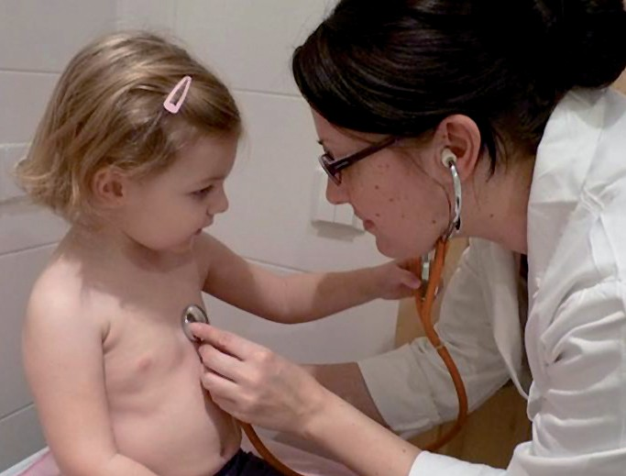

Immunisation
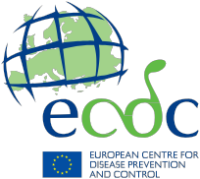

Information for parents and caregivers

What is community immunity and why is it important?

Community immunity

Vaccination protects you and your family, and it also helps protect others. It contributes to ‘community immunity’. This is achieved when enough people in a population are immune to an infectious disease (through vaccination and/or prior illness) so that it is unlikely to spread from person to person. Even those who cannot be vaccinated because they are too young, are allergic to vaccine components, or vaccination is contraindicated for them, are offered some protection because the disease cannot spread in the community and infect them. This is also known as ‘herd immunity’.

When enough people are protected (blue dots) in a community they can protect those who are not yet vaccinated (yellow dots) from those who are infectious (red dots).

When groups of unvaccinated people build up and are in close proximity, community immunity doesn’t work and the disease spreads.

Prevention of outbreaks
© David Sim, www.flickr.com/photos/victoriapeckham/164175129

Low measles vaccination uptake in a group of people can lead to dramatic increases in measles infections. This has happened in some areas and specific communities in Europe and has led to measles outbreaks. Because measles is highly contagious, it is important to achieve high levels of immunity in all communities in order to prevent and control this disease.

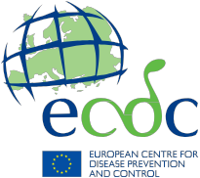

Information resources on vaccines and immunisation
ECDC factsheet for the general public – Measles www.ecdc.europa.eu/en/healthtopics/measles/Pages/factsheet-general-public.aspx

ECDC vaccination gateway
ecdc.europa.eu/en/eurovaccine

ECDC’s interactive platform for vaccine schedules
vaccine-schedule.ecdc.europa.eu

Further link recommendations (insert as appropriate)

Link description max two lines
Link

Link description max two lines
Link

