Immunisation
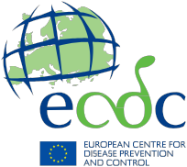

Information for parents and caregivers

The immunisation visit
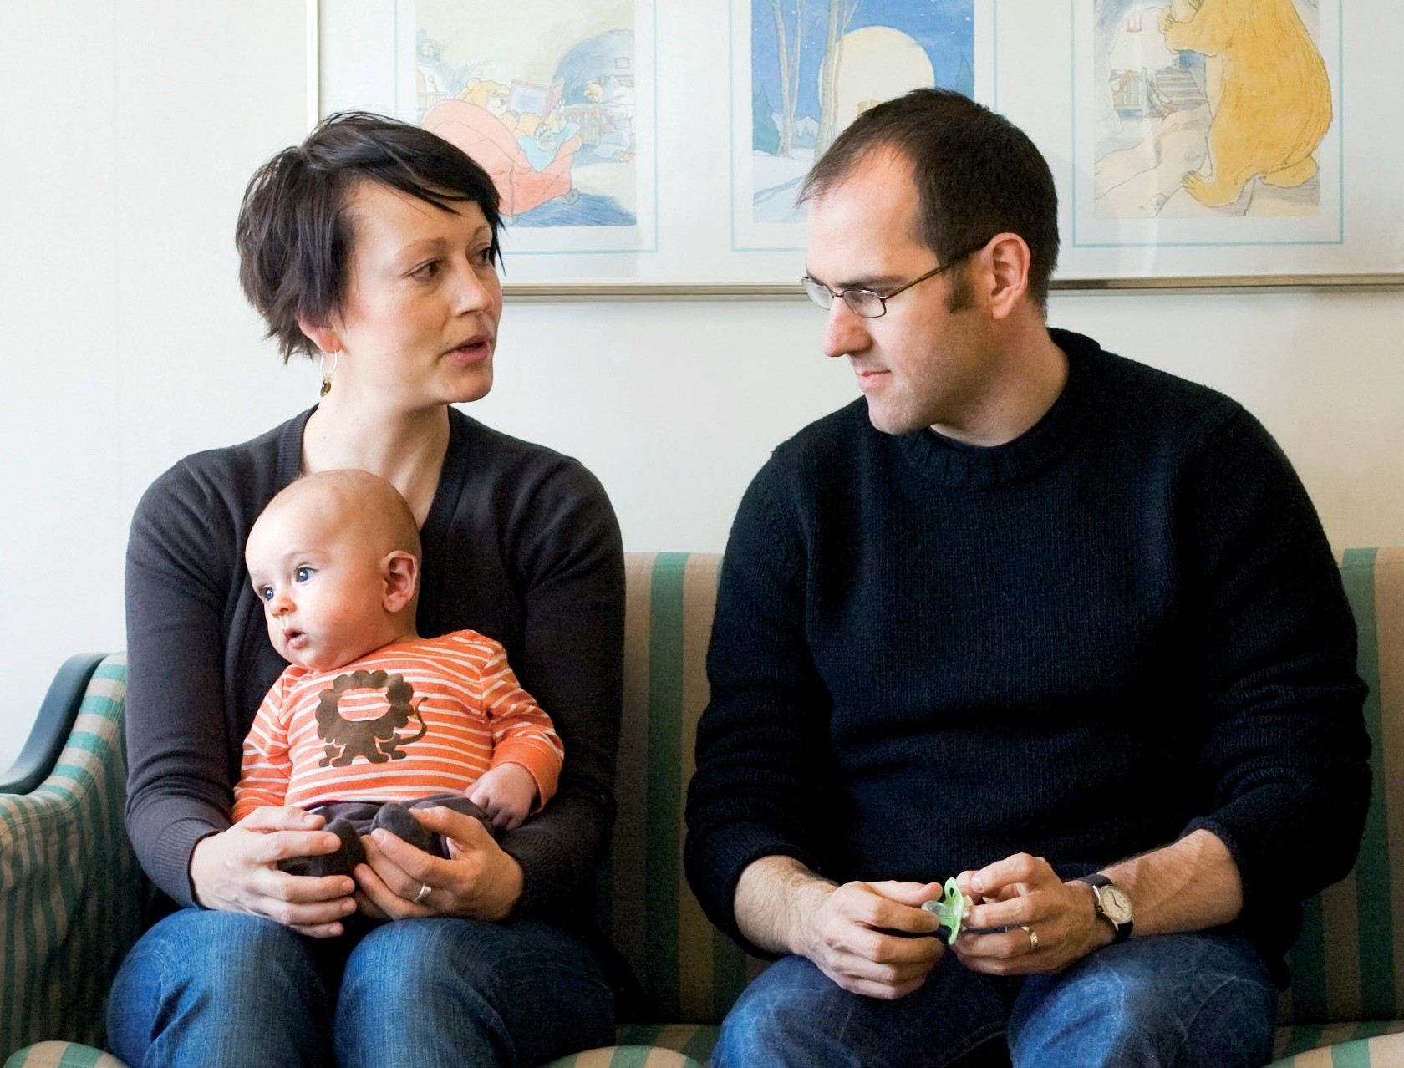

To help you prepare for your child’s vaccinations, this leaflet provides a checklist of the key questions and information that can be addressed during the immunisation visit. It also provides you with important information to be aware of following a vaccination session.

A. Before the immunisation visit

1 If you have a vaccination card or book for your child, bring it with you so you have an accurate record of the vaccinations given. If you do not have a vaccination card or book then ask for one. It could be useful later to keep track of which vaccinations were received and which are pending. Your child’s vaccines may also be entered into an electronic registry.

2 Be prepared to answer questions about allergies, previous reactions to a vaccine or other health problems.

B. During the immunisation visit

1 Your provider will ask you some questions (or give you a short questionnaire to fill out) to make sure that your child is well and able to get the scheduled vaccination. If your child has a fever or severe cold or other illness, you might be asked to postpone vaccinations until she/he gets better.

2 Your provider will give you information about each vaccine your child receives, including its risks and benefits. Always ask your provider if you have any questions or would like more information.

3 Your provider might ask you to hold your child in a certain way to steady the arm or leg where the injection will be given. These techniques help to keep the child still.

4 Make sure that any vaccinations that are given are recorded in your child’s immunisation record and that you know when to come back for the next vaccinations. The vaccine provider may be able to send you reminders.

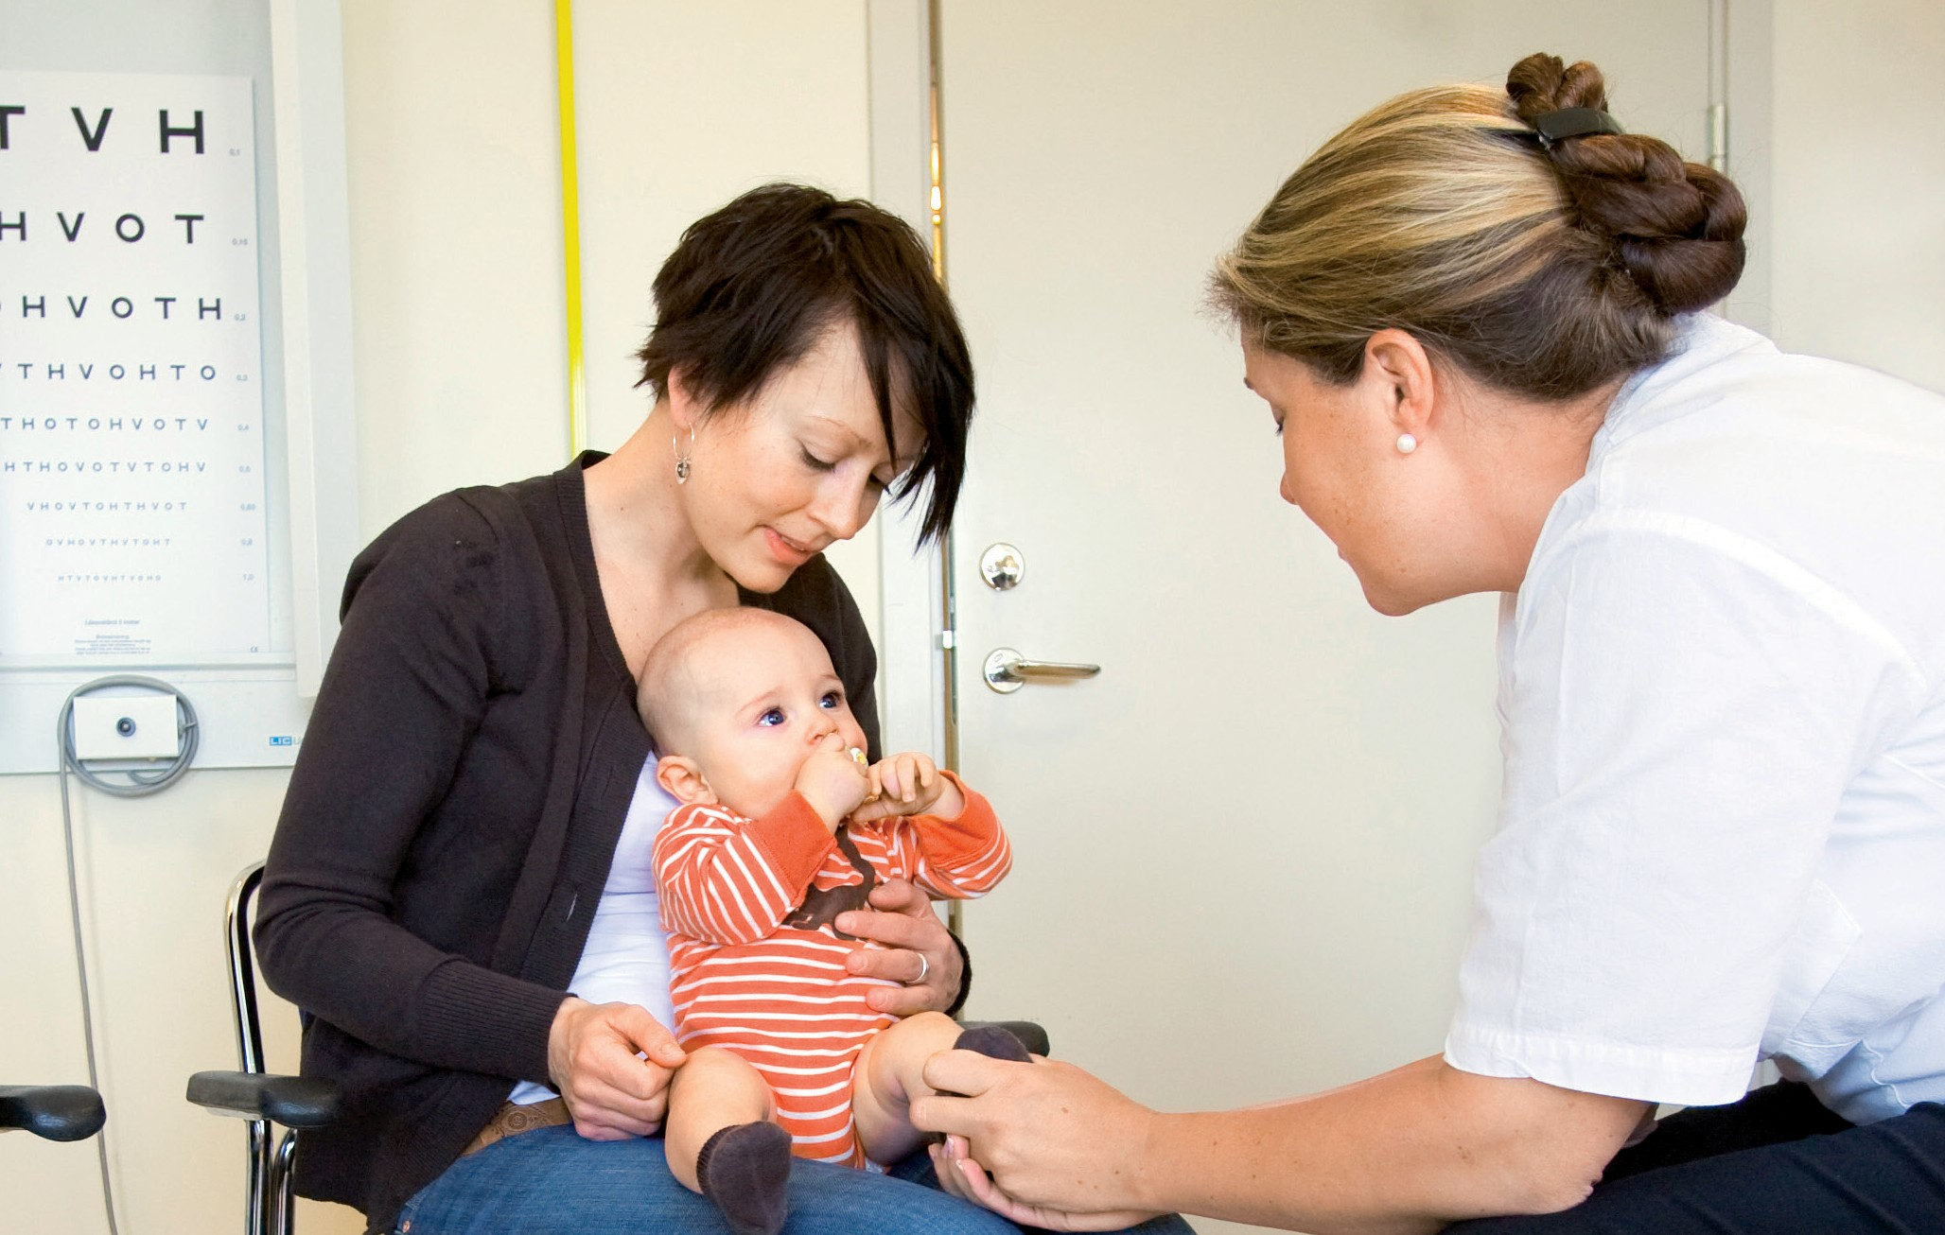

C. After the immunisation visit

1 Sometimes a child could have a sore leg or arm (where the injection was given) or develop a fever after an immunisation visit. Ask your healthcare provider what to do if this happens.

2 Your healthcare provider can tell you how to monitor your child after the vaccination session.

Content adapted from the original by the U.S. Department of Health and Human Services’ website vaccines.gov: www.vaccines.gov/getting/expect/for_children/#

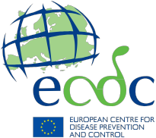

Information resources on vaccines and immunisation
ECDC vaccination gateway ecdc.europa.eu/en/eurovaccine

ECDC’s interactive platform for vaccine schedules
vaccine-schedule.ecdc.europa.eu

Further link recommendations (insert as appropriate)

Link description max two lines
Link

Link description max two lines
Link

Vaccination protects you and your family. By vaccinating you contribute
to a healthy community.

