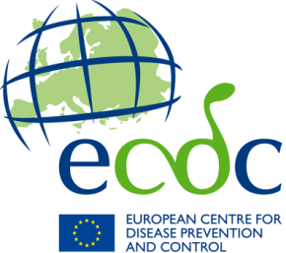
ECDC Observership programme

Expression of interest

Documents to be submitted:
The application should be written in English. For the application to be considered valid, the following documents must be submitted:
- The completed application form;
- The completed eligibility form;
- A detailed description (up to 5 pages) of the scope and mission of the organisation, the area of work, the activities supporting career development and the funding opportunities for members to participate in continuous professional programme or other training programme;
- Any evidence supporting the application.

Please send the application and required attachments:
To: css@ecdc.europa.eu and Barbara.albiger@ecdc.europa.eu
Subject line: ECDC observership call for interest: Application

- Application Form

Name of the organisation
Address of the organisation
Telephone number
Name of contact person
Email address
Website
Scope of the organisation
Area of work

(1) | Be a public or non-commercial, non-profit organisation | Yes ☐ | No ☐
(2) | Operate in the remit of ECDC’s work and in the field health (e.g., public health, clinical microbiology, virology and parasitology, clinical research, infection prevention and control etc) | Yes ☐ | No ☐
(3) | Be an European umbrella entity | Yes ☐ | No ☐
(4) | Be located in the EU/EEA, the EU enlargement countries as well as European Neighbourhood policy partners | Yes ☐ | No ☐
(5) | Have a continuous professional development programme or initiative for their members | Yes ☐ | No ☐
(6) | Can oversee the application and selection process of the observers | Yes ☐ | No ☐
(7) | Can provide full funding to support the observers visits (i.e., travel, accommodation and living costs for five days in Stockholm) | Yes ☐ | No ☐
(8) | Can oversee the funding and reimbursement process. | Yes ☐ | No ☐

- Eligibility form
Please indicate either Yes or No below; failing to answer ALL QUESTIONS will render your application invalid

- Detailed description (scope and mission, area of work, the training activities and the funding opportunities for members)

- Evidence (supporting the application)

