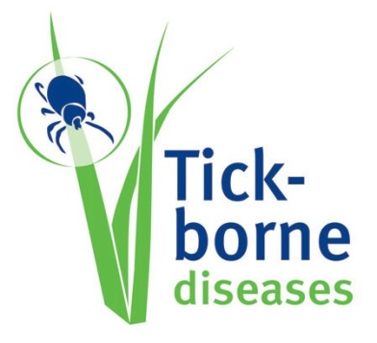

Poster for children – short version

BE TICK FREE

1. USE INSECT REPELLENTS
2. COVER UP
3. AVOID LONG GRASS OR BUSHES
4. CHECK YOURSELF FOR TICKS
5. REMOVE THE TICK QUIKLY
6. DISINFECT

WHAT IS A TICK?
TICKS ARE SMALL, INSECT-LIKE CREATURES
Normally, they bite wild animals but they can bite humans and your pets too.

WHY AVOID TICK-BITES?
ONCE A TICK BITES YOU IT USUALLY STAYS ON YOUR BODY FOR A FEW DAYS
A tick-bite will only itch a bit, but some ticks can carry diseases that can be passed on to you. That is why it is very important to try to avoid being bitten by ticks – and to remove them quickly if it does happen.

