Measles is a serious disease

Measles is not a harmless childhood disease. It is a highly contagious viral disease that spreads easily among unvaccinated people. Symptoms usually appear 10 to 12 days after infection, initially resembling a cold, with a runny nose, cough and a slight fever. The eyes become red and sensitive to light. As the illness progresses, and usually on the third to seventh day, the temperature may reach 39 – 41 °C, and a red rash appears that lasts four to seven days.
Approximately 30 % of reported cases
have one or more complications, especially
among children under five years of age and adults over 20. Measles can be more severe in people with weakened immune systems.

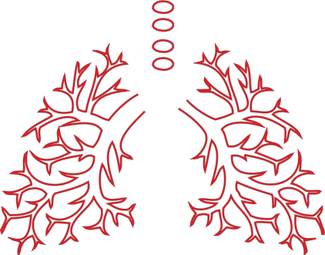Complications from measles infection

7 to 9 out of 100 children develop ear infection, which can result in hearing loss.

1 in every 1 000 patients develop acute encephalitis (swelling of the brain). This can lead to convulsions and leave a child deaf or with mental
disability.
8 out of 100 patients report diarrhoea.

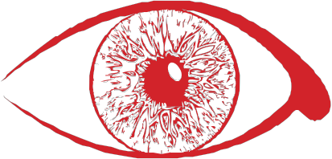Eye disorders, such as destruction of the cornea (outer layer of eyeball) may lead to blindness. This condition affects,
in particular, malnourished children and is

linked to vitamin A deficiency.
1 to 6 out of every 100 patients suffer from pneumonia. This is the most common cause of death from
measles in young children.

A rare but fatal brain complication known as subacute sclerosing panencephalitis
(SSPE), can occur several years after measles.

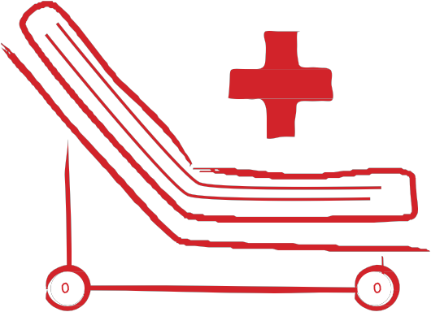1 out of 4 people who get measles will need
hospitalization.
Up to 1 in 1 000 measles patients die as a result
of the disease.

Source: ECDC. Measles and rubella elimination: Communicating the importance of vaccination. Stockholm: ECDC; 2014. Available at: ecdc.europa.eu/en/publications/Publications/Measles-rubella- elimination-communicating-importance-vaccination.pdf

www.ecdc.europa.eu
Measles vaccination protects you and your family. By vaccinating against measles you contribute to a healthy community.

