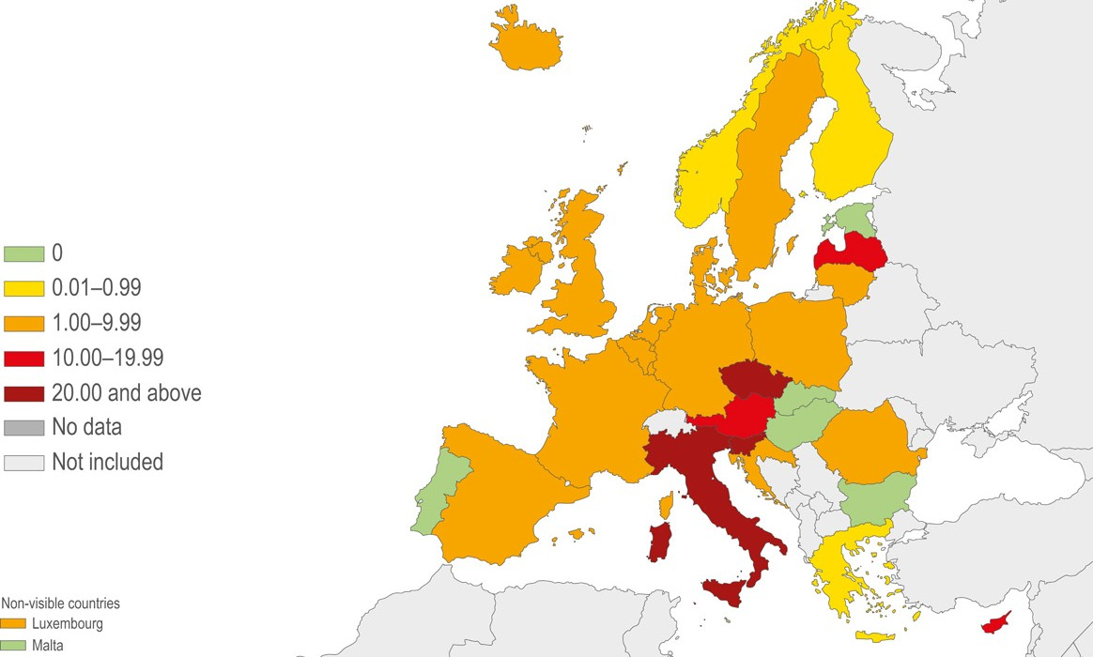

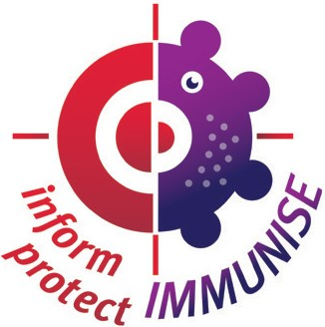

Measles is a serious disease – Vaccination is the only
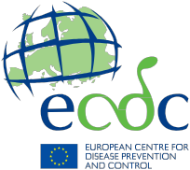

effective protection

Measles outbreaks
still occur in Europe

Measles has become rare in Europe compared to some other regions in the world, thanks to vaccination. Many people, including healthcare workers, may never have even seen a person with measles. This can give rise to a belief that the disease has been eliminated. But measles outbreaks continue to occur in many parts of Europe. An estimate of one out of four people with measles will need hospitalisation and every year several people die in Europe as a consequence of measles infection.

Measles notification rate (cases per million) by country, January to December 2014,
EU/EEA* countries (n = 3 616)

*EU/EEA: European Union/European Economic Area

30 % of cases develop
complications
Measles is highly infectious
and can be severe

Complications range from ear infections, diarrhoea and dehydration, to pneumonia and can involve lifelong consequences such as blindness and brain damage from encephalitis. Most measles-related deaths are due to complications
of measles.

Measles spreads easily
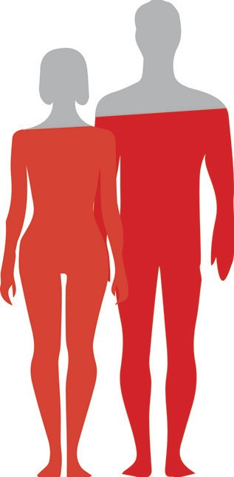

An unvaccinated person who is exposed to measles has a 90 % probability of becoming sick. This is regardless of age and the
‘strength’ of her or his immune system. Vaccination is the only measure that prevents infection. There is no scientific evidence that natural remedies, diets or lifestyle changes reduce the risk of measles.

90%
among those
not protected

probability
of contracting measles if
not vaccinated

an average of
1 person 12 to 18
with measles can infect unprotected people

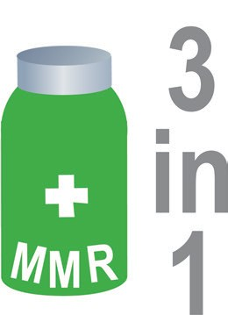
A combination vaccine
protects against measles, mumps and rubella

The MMR (measles, mumps and rubella) vaccine is a combination vaccine that protects against the three diseases with only one shot. Some people fear that combination vaccines or giving
several vaccines at the same time overloads a child’s immune system or increases the risk of harmful side effects. But all combination vaccines have been thoroughly tested against giving the vaccines as separate shots, and there is convincing evidence that the combination vaccines
do not significantly increase the risk or reduce the protection.

2 doses of MMR vaccine are recommended to
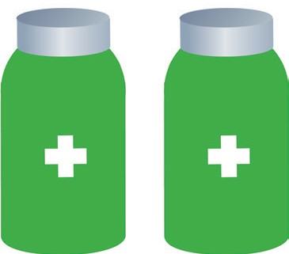

protect against measles

It is much safer to be vaccinated than to develop immunity by getting infected with measles. Measles vaccine protects without the risk of the severe illness, complications and death that comes with having the disease. There is no evidence that having natural disease is an advantage that justifies not getting vaccinated. National schedules differ but all countries recommend that the first dose is given during the second year of life (age 12 to 24 months).

Immunity through vacci- nation protects not only the immunised individual but also unvaccinated people in the community, such as infants that are too young to be vaccinated.
Immunity through the disease exposes other unvaccinated people to the risk of the disease before and during the time of infection, and comes with the risk of severe complications.

The MMR vaccine has an excellent safety record. Vaccinations, as every other pharmaceutical substance, entail a certain probability of side effects. Side effects, such as fever or local swelling at the site of injection, are usually mild, and more severe reactions are very rare.

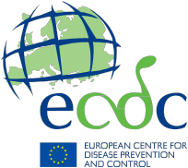

Information resources
on vaccines and immunisation
ECDC vaccination gateway ecdc.europa.eu/en/eurovaccine

ECDC’s interactive platform for vaccine schedules
vaccine-schedule.ecdc.europa.eu

ECDC factsheet for general public – Measles
ecdc.europa.eu/en/healthtopics/measles/Pages/factsheet-general-public.aspx

Reference

The content of this leaflet is based on the ECDC report: Measles and rubella elimination: Communicating the importance of vaccination. Stockholm: ECDC; 2014. Available at:

ecdc.europa.eu/en/publications/Publications/Measles-rubella-elimination- communicating-importance-vaccination.pdf

Measles vaccination protects you and your family. By vaccinating against measles you contribute to a healthy community.

-

